# Media Analysis - No need to demonize ChatGPT but AI regulation is a must

## Short Summary

The article discusses ChatGPT's capabilities across various sectors, its potential to enhance or threaten jobs, its limitations, and the necessity for AI regulation.

## Summary

1. **Opportunities**: ChatGPT, developed by OpenAI, has the ability to understand and respond to natural language, making it a valuable tool in various industries, including journalism. It can generate essays, articles, reports, poetry, explain complex scientific subjects, and even create recipes within seconds.  
2. **Potential Impact on Education**: ChatGPT is causing concern among educators due to its potential for plagiarism and lack of original content. Students are finding ways to circumvent this issue by using nuanced questions or oral exams, leading to a transformation in teaching methods.  
3. **Journalistic Concerns**: The use of AI in journalism raises fears about job displacement and the potential for errors in AI-generated content. A CNET experiment with AI-written articles highlighted these concerns but also demonstrated that human corrections are necessary.  
4. **Medical Implications**: ChatGPT has shown proficiency in medical domains, passing parts of the US Medical Licensing Examination. While it's believed to augment rather than replace doctors, ethical and copyright issues arise from AI-generated literature and art.  
5. **Limitations**: Despite its capabilities, ChatGPT is not perfect and makes mistakes with complex prompts or outdated information. It also has self-imposed rules for generating friendly content.  
6. **Need for Regulations**: The article suggests that while fears about AI's impact on employment are legitimate, they may be overstated. Proper regulation is crucial to ensure AI benefits everyone, particularly those in developing countries with limited resources.

## Question 1:

How do the media (in our case = the sample we are analyzing) frame the public discussion about ChatGPT? Are there certain **metaphors** that keep cropping up?

1. 'AI and the new ChatGPT mania' This metaphor frames the topic as a widespread phenomenon, comparing it to a mania or fad that has captured public attention and interest. 2. 'Changing modes of instruction' in education This metaphor describes the shift towards different teaching methods due to AI's impact on education, suggesting a transformation or evolution in the educational landscape. 3. 'Journalistic disaster' The use of this metaphor highlights the potential negative consequences of AI-generated content, positioning it as a crisis or failure within journalism.

## Question 2:

Which role does the Arabic World play in the field of Artificial Intelligence in this article according to the author? Answer with 'Not mentioned' if not applicable.

Not mentioned

## Question 3:

How helpful is Artificial Intelligence for the Arabic world based on this article?

According to the article, Artificial Intelligence, specifically tools like ChatGPT, could be highly beneficial for the Arabic world. Its applications range from generating news articles and educational resources to creating literature. However, concerns are raised about its potential negative impacts on journalism, education, and medical professions in terms of plagiarism, lack of original content, and job displacement. Nonetheless, AI has the potential to be a 'great equalizer', helping under-resourced regions or individuals in science by providing access to resources and information they might not otherwise have.

## Question 4:

What is the final message of the article that the author wants to convey? Keep your answer short and precise!

Regulation is necessary for AI technologies like ChatGPT to ensure they are used responsibly and do not cause harm.

## Sentiment

The sentiment is -5

## Entities

The New York Times, Arab News', The Washington Post, Amal Mudallali, CNET, Disclaimer Views, Midjourney, AI, Post, Generative Pretrained Transformer, fed, Google, Springboard, READ Learning, OpenAI, BBC, ChatGPT

## Topic Clusters

### Cluster: AI advancements and ChatGPT capabilities

AI advancements, ChatGPT capabilities

### Cluster: AI in Media and Content Generation

AI-generated content, Journalism impact

### Cluster: Societal Transformations

Education transformation

## Word Clouds

### Wordcloud of content

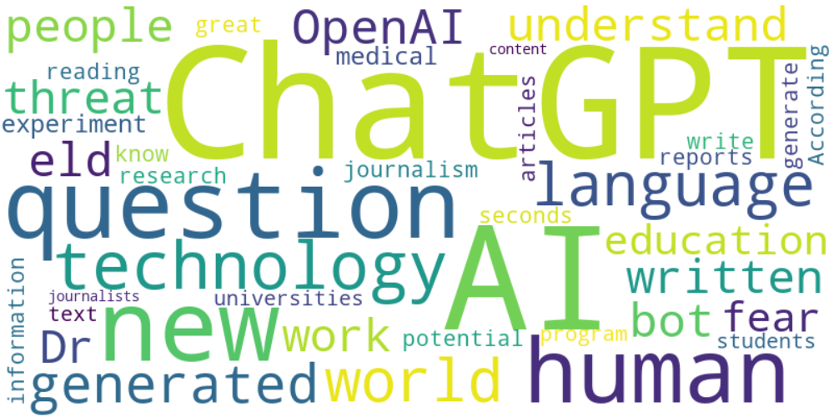

Top 10 words:

- ChatGPT: 28

- AI: 24

- human: 7

- technology: 6

- language: 5

- news: 5

- world: 5

- generated: 5

- OpenAI: 4

- understand: 4

### Wordcloud of summary

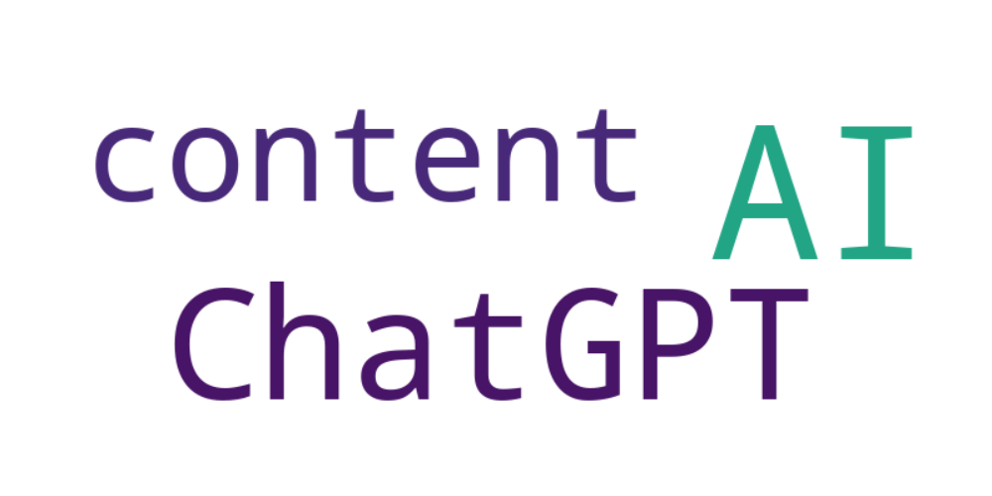

Top 10 words:

- AI: 6

- ChatGPT: 4

- content: 3